Grades: 3 & 4

Guiding Question
How do plants differ in their growth from seed?

Timing
20 minutes to set up sprouting and a few weeks to observe the process.

MA STE Standards addressed in lesson
3-LS1-1: Use simple graphical representations to show that different types of organisms have unique and diverse life cycles. Describe that all organisms have birth, growth, reproduction, and death in common but there are a variety of ways in which these happen.
4-LS1-1: Construct an argument that plants have internal and external structures that support their survival, growth, behavior, and reproduction.
Experimenting with Seeds Lesson Plan
Materials Needed
Various seeds including: dried beans, popcorn, or any other organic seed from a package.
Large Jar for soaking beans.
See-through plastic cups for planting seeds.
Paper towels.
Magnifying glasses (optional)
White and colored construction paper to make Seed Growth Journals

Overview
The goal of this activity is to have students observe seed sprouting and the growth of the first set of leaves for different types of plants.

Procedure
- On the day before you plan to do this lesson place some beans in a jar and cover them with water about an inch above the beans. Allow the beans to soak overnight. The next morning, drain the beans for the students.
- Discuss with students the plant life cycle. A graphic has been provided at the end of this lesson that may be a useful handout for students. Explain that they are going to plant some seeds to observe changes over the next several weeks.
- You might want students to make Seed Growth Journals using white paper and construction paper folded in half, and stapled along the folded edge to make a little book. This is where they can record their observations.
- First, have each student carefully examine one of the soaked beans. They should first remove the outside seed coat (usually colored), then gently pry apart the bean along the split on the rounded side of the bean. Inside they should see tiny structures which look like very small pale leaves, stem, and a root. These are the embryonic structures that do form these parts of the plant when germination occurs. Allow the students to use magnifying glasses to look at the tiny plant if you have them. If using Seed Growth Journals, have the students draw what the inside of the bean looks like to them.

- Students can then choose seeds (different than the ones they dissected) to plant in a plastic cup to observe growing.
- For each student’s plastic cup, fold a sheet of paper toweling and line the inside of the cup with it. Wad sheets of paper toweling and stuff them into the cup to hold the paper lining tightly against the cup. Place the seeds along the edge of the cup. You can put different kinds of seeds in the same cup, but space them about an inch apart. Moisten the paper in the cup with water. You do not want the paper to be dripping wet—only moist.
- Keep the paper moist and observe the seeds. Have students record changes they notice:
  - Do the seed roots grow at different rates? (use a ruler to measure growth each day)
  - What do the roots look like? fuzzy vs. stringy?
  - How many leaves emerge—one (popcorn or grass seeds) or two (beans or peas)?
  - What color changes do they notice between the root and the leaf/stem sprouts even though in the bean the embryo was all white?
- There are many options for this growth experiment, depending on the interest of the students. Ask them what they would like to know and try it out!
- Good resource: Biology for Every Kid—101 Easy Experiments that Really Work by Janice VanCleave.

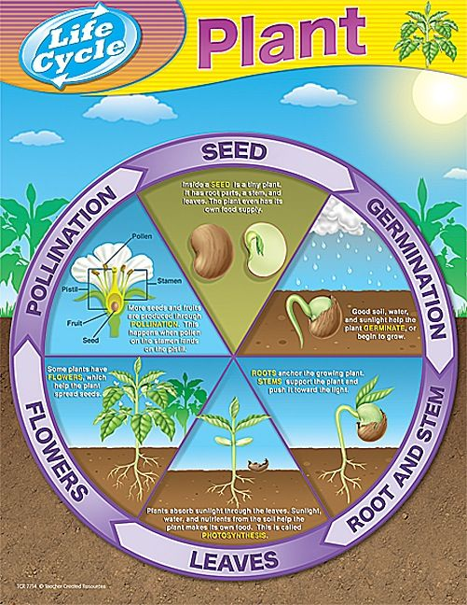
Good soil, water and warmth help the plant germinate, or begin to grow.
Roots anchor the growing plant. Stems support the plant and push it towards the light.
Plants absorb sunlight through the leaves. Sunlight, water and air help the plant make its own food. This is called Photosynthesis.
Seeds are produced through pollination. This happens when pollen from the stamen lands on the pistil.
Some plants have flowers, which make seeds for new plants.
Inside a seed is a tiny plant. It has root parts, a stem, and leaves. The plant even has its own food supply.

