Grades: 3 & 4

Guiding Question
What changes do you notice as different plants grow?

Timing 30 minutes

MA STE Standards addressed in lesson
3-LS1-1: Use simple graphical representations to show that different types of organisms have unique and diverse life cycles. Describe that all organisms have birth, growth, reproduction, and death in common but there are a variety of ways in which these happen.
4-LS1-1: Construct an argument that plants have internal and external structures that support their survival, growth, behavior, and reproduction.
Seeing Plants Grow Lesson Plan
Materials Needed
Computer with internet access to project the video clip.
Hand out of Plant Life Cycle.

Overview
The goal of this activity is to help students visualize the plant life cycle. It is difficult to understand how plants move through their life cycle because it happens so slowly it cannot be directly observed in real time. The use of time-lapsed videos will help students to literally see plants growing and how they move from one stage to another in their life cycle.

Procedure
- Discuss with students the plant life cycle. The graphic at the end of the lesson may be useful as a handout for students to refer to as you go through the life cycle.
- When we look at a plant, it is hard to observe it grow and change as we watch it because plants do this slower than we can see with our eyes. However, scientists who study how plants change over their lifetime, need to make these careful observations. So, they devised a way/method for being able to “see” plants grow. It is called time-lapse photography where a camera sits in one place and takes a photo every 5 minutes (or some constant time interval), then they put them all together into a video to see the plant move. We are going to look at some of these videos to see how plants change through their life cycle.
- Watch the video of seeds to plants (1:07) as a general overview of different parts of the plant life cycle.

- You should watch the video a few times, pointing out the plant parts as they emerge and grow—leaves from a bud, flowers from a bud, maple seeds sprouting from the samaras, a vine wrapping around a support. The sunflower towards the end shows the emergence of the root tip, the root hairs developing as they go into the ground then the stem and leaves emerge, with the final flower blooming.
  - Have an open discussion of what the children see/observe. Encourage the children to support any conclusions/interpretations on what was presented in the video to encourage the use of evidence since this is a science discussion. Then have them look for additional evidence of differences between plants as they move through their life cycle in the following videos that are more targeted at certain life stages.
- Now take a closer look at the beginning parts of the life cycle: germination, roots and stems, leaves. This video (1:43) shows various plants sprouting then growing. The first seeds are peas, then beans, and finally grass. Be sure to point out the root shoot going down into the soil and the stem shoot going up towards the light. As the leaves emerge there is a lot of movement to orient the leaves towards the sun for photosynthesis.
- This other short video (0:42) shows the growth of a vine and how it spins around until it finds something it can climb.
- This set of three videos show various seed development and dispersal strategies. This video (1:40) takes the common dandelion through bloom to seed. This shows how there is a gathering up of the flower parts as the seeds begin to form and seeds being dispersed by wind. This last narrated video (1:54) shows explosive dispersal of seeds of the common violet, touch-me-nots, and squirting cucumber (the sounds were added for effect—the plants only emit a very light pop, if any sound, when they explode).
- Conclude by discussing the similarities and differences the students noticed between the plants in the sprouting, growth and seed formation. You might want to place these lists on a chart in the classroom.

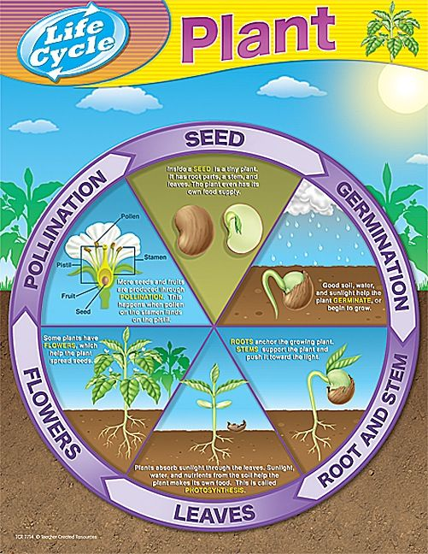
Good soil, water and warmth help the plant germinate, or begin to grow.
Roots anchor the growing plant. Stems support the plant and push it towards the light.
Plants absorb sunlight through the leaves. Sunlight, water and air help the plant make its own food. This is called Photosynthesis.
Seeds are produced through pollination. This happens when pollen from the stamen lands on the pistil.
Some plants have flowers, which make seeds for new plants.
Inside a seed is a tiny plant. It has root parts, a stem, and leaves. The plant even has its own food supply.

